
English for Business Communications
End of Cycle Assessment: Cycle 7 2025
Case Study: Waterford Wedgeworth
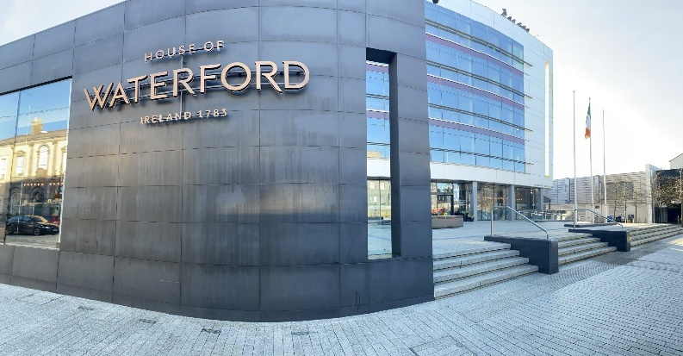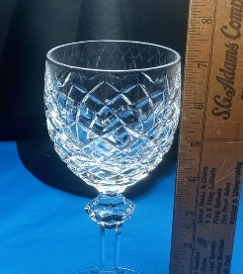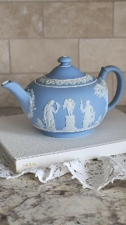
1. In the landscape of Irish business, few names have carried as much cultural and commercial weight as Waterford Wedgwood. Renowned for exquisite crystal glassware and fine ceramics, the company represented craftsmanship, heritage, and premium luxury. For decades, the brand stood as a beacon of Ireland’s manufacturing excellence, especially through its flagship product — Waterford Crystal. Yet, despite a strong brand and international prestige, its ambitious diversification strategy in the late 20th and early 21st centuries led to financial overextension and eventual collapse. The story of Waterford Wedgwood’s failed international expansion offers rich lessons in strategic management, market adaptation, and the challenges of competing globally from a small domestic base.
2. The company’s origins date back to 1783, when master glassmakers founded a crystal factory in Waterford. Its reputation for quality craftsmanship spread quickly throughout Europe, and Waterford crystal became a symbol of refinement, frequently appearing on aristocratic tables and in luxury settings. After a long hiatus due to economic conditions in the 19th century, production was revived in 1947 by a group of Irish entrepreneurs. In the decades that followed, Waterford grew into one of Ireland’s most prominent exporters. By the 1970s, the company had become synonymous with high-end crystal, exporting to North America, Europe, and Asia. A major turning point came in 1986, when Waterford acquired Wedgwood — the iconic English pottery company founded by Josiah Wedgwood in the 18th century. This merger created Waterford Wedgwood, a luxury tableware group with global reach, strong brand recognition, and premium positioning.
3. The newly formed company’s leadership saw itself not merely as a crystal or ceramics producer, but as a global luxury lifestyle brand. Throughout the 1990s and early 2000s, its strategy involved Acquisitions and brand extensions. In addition to Wedgwood, the group acquired luxury brands such as Royal Doulton and Rosenthal (a German porcelain manufacturer). The aim was to broaden its portfolio beyond glassware and ceramics to cover the entire luxury homeware spectrum.it also involved Geographic diversification. Waterford Wedgwood expanded aggressively into North America, continental Europe, Japan, and emerging markets. The United States, in particular, became its single largest market — accounting for nearly half of total sales at one point. Similarly, to compete on cost, Waterford Wedgwood began outsourcing some production to Eastern Europe and Asia, while keeping its high-end and flagship lines in Ireland and England.
4 The company moved beyond traditional crystal and bone china into kitchenware, lighting, home décor, and fashion accessories. It sought to emulate the lifestyle brand strategy used successfully by companies like Ralph Lauren. The company invested in branded retail stores in key global cities. These were often located in expensive prime locations, from Fifth Avenue in New York City to luxury malls in Tokyo. The aim was to control the customer experience and capture more of the retail margin.

5 At first glance, this strategy seemed sound. Luxury goods markets in the 1990s were expanding, and globalisation promised access to new consumers. However, several external forces undermined the company’s international ambitions. From the late 1990s, younger consumers — especially in the United States — began to favour casual dining and minimalist design over formal crystal and porcelain dinnerware. Demand for elaborate table settings and ornate crystal declined steadily. While brands like IKEA and Crate & Barrel thrived by offering stylish but affordable homeware, Waterford Wedgwood was anchored in a luxury segment that was shrinking outside its traditional base. The international homeware and giftware market became crowded. Cheaper producers from Eastern Europe and Asia eroded Waterford Wedgwood’s market share, while global luxury conglomerates such as LVMH Moët Hennessy Louis Vuitton captured the aspirational luxury market with better branding and marketing muscle. Overreliance on the US market left the company vulnerable to downturns. After the early 2000s recession and again during the 2008 financial crisis, American consumers sharply reduced spending on luxury tableware. Sales collapsed, and the company lacked sufficiently diversified revenue streams to cushion the blow.

6. External pressures alone do not explain the failure. A series of internal strategic missteps amplified the company’s vulnerabilities. The acquisition of Wedgwood, Royal Doulton, and Rosenthal stretched the company’s balance sheet. These were mature brands with declining core markets — not engines of growth. Integrating these disparate brands across multiple countries proved expensive and complex. Waterford Wedgwood was slow to innovate in design, materials, and product range. Its core offerings remained traditional, while consumer tastes moved toward contemporary, multifunctional, and sustainable products. Limited investment in R&D and weak responsiveness to market trends meant the company struggled to attract younger consumers. Production costs in Ireland and the UK remained high. While outsourcing some lines helped, the company continued to operate costly manufacturing plants to maintain its “Made in Ireland” and “Made in England” heritage branding. This eroded margins when volumes fell.
The global retail store strategy proved expensive to maintain. Many stores in high-end locations failed to generate enough revenue to justify the costs. The company also underestimated the rise of online retail and new distribution channels.
7. Throughout the late 1990s and early 2000s, the company’s revenue growth slowed, even as its debt and operating costs grew. By 2007, it had posted multiple years of losses. Attempts to restructure and cut costs were too slow and too limited. The 2008 global financial crisis delivered the final blow. As American and European consumers slashed spending, sales of luxury tableware plummeted. The company’s cash flow collapsed. With more than €800 million in debt and dwindling investor confidence, Waterford Wedgwood entered receivership in January 2009.The collapse was a national shock in Ireland. Hundreds of jobs were lost at the iconic crystal plant in Waterford, and the failure tarnished the image of a brand once considered untouchable.
8. Although the company itself failed, its brands survived through new ownership. The assets were acquired by KPS Capital Partners, a US-based private equity firm, which created WWRD Holdings (Waterford, Wedgwood, Royal Doulton). Later, in 2015, WWRD was acquired by Fiskars Group, a Finnish consumer goods company. Under Fiskars, production was scaled down, many retail operations were closed or streamlined, and the brands were repositioned to fit more contemporary tastes. Production at the original Waterford plant was significantly reduced, with much manufacturing moved abroad. The Waterford Crystal visitor centre remained as a tourist attraction, but the brand ceased to be a major Irish manufacturing employer.
9. Waterford Wedgwood’s strategy was based on the assumption that demand for luxury tableware would remain stable or grow globally. In reality, consumer tastes shifted away from formal entertaining. The company failed to anticipate this cultural change. Heritage can be a powerful asset, but in this case, it became a constraint. The company hesitated to modernise product lines or reposition the brand for fear of diluting its image. Competitors were more nimble in adapting to new trends. Although the company expanded internationally, it remained heavily dependent on the US market and luxury tableware as a product category. This was not true diversification, but a replication of the same product strategy across multiple geographies. International diversification requires flexibility. Waterford Wedgwood’s cost structure — expensive retail stores, multiple factories, legacy overhead — left little room to adapt when sales fell. While competitors invested in e-commerce and global marketing platforms, Waterford Wedgwood remained tied to traditional retail channels. This limited its reach to new, younger consumers globally.
10. The Waterford Wedgwood story provides valuable lessons for other Irish firms with global ambitions. Simply selling the same product in more countries does not constitute true diversification. Businesses need to adapt offerings to local markets, broaden their product mix, and build resilience against regional economic shocks. Irish brands with strong heritage must find ways to honour their identity while evolving. Heritage can attract consumers, but it should not prevent modernisation. International competition often involves cost pressures. Relying on high-cost domestic manufacturing while competing with global players can be fatal unless offset by unique value or premium pricing that consumers are willing to sustain. The failure to understand changing consumer habits — particularly among younger demographics — left Waterford Wedgwood stuck in a shrinking niche. Ongoing investment in consumer insight is essential for strategic agility. Modern international expansion requires strong online sales, digital branding, and marketing capabilities. Traditional retail footprints alone are insufficient.
11.Ireland’s economy has long relied on exports, particularly in sectors like technology, pharmaceuticals, and agri-food. But Waterford Wedgwood’s collapse highlights a critical challenge for Irish heritage brands. Competing internationally requires more than craftsmanship — it requires adaptive strategy, digital engagement, and scalable business models. Irish companies often emerge from small domestic markets and need to “go global” early. But this can also leave them exposed if they lack diversified product lines and flexible structures. Policymakers and support agencies can play a role in helping heritage brands modernise, innovate, and remain competitive internationally.
12. The failure of Waterford Wedgwood’s international diversification strategy was not inevitable. It was the product of strategic overreach, market misjudgement, and operational inflexibility. The company expanded internationally but did not truly diversify. It relied too heavily on a shrinking product category, underestimated changing consumer behaviour, and was burdened by high costs and legacy structures. Today, the Waterford brand still exists — but as a shadow of its former industrial self, now owned by a foreign conglomerate. For Irish businesses looking outward, this case stands as a cautionary tale: going global can be a growth engine, but without strategic adaptation, it can also accelerate decline.

IELTS-Style Reading Questions
Part 1: Matching Headings
Match the following headings (A–F) to paragraphs between 1–12 in the article. Use each heading only once.
- Lessons for Irish Businesses Seeking International Growth
- Aftermath and Brand Survival
- Strategy of International Diversification
- Internal Strategic and Operational Missteps
- Market Context and External Pressures
Part 2: Multiple Choice
Choose the correct answer (A, B, C, or D).
6. What was one of the main goals of Waterford Wedgwood’s international diversification strategy in the 1990s?
A. To focus exclusively on Irish domestic sales
B. To become a global luxury lifestyle brand
C. To reduce its product range to only crystal glassware
D. To abandon retail operations altogether
7. Which of the following best explains why Waterford Wedgwood struggled in international markets?
A. There was no demand for luxury products anywhere in the world.
B. The company focused too much on modern design and lost its traditional customers.
C. It failed to adapt to changing consumer tastes and relied too heavily on heritage branding.
D. Its online marketing strategy was too aggressive.
8.Which external factor contributed most to the company’s decline in the 2000s?
A. Declining global luxury markets and cheaper competitors
B. Sudden shortage of skilled craftsmen in Ireland
C. Overproduction of crystal glass in Asia
D. Legal restrictions on exporting Irish goods
9. What is one key lesson for Irish companies from Waterford Wedgwood’s failure?
A. International expansion guarantees financial success.
B. Heritage brands should never change their product design.
C. Diversification should include product innovation and market adaptation.
D. Digital transformation is unnecessary for luxury brands.
10. Which of the following factors most intensified the impact of the global financial crisis on Waterford Wedgwood?
A. Its early investment in digital sales channels
B. Its high dependency on the US luxury market
C. Its decision to stop outsourcing production
D. Its strong focus on contemporary product design

Part 3: True/False/Not Given
Decide if the statements below are True, False, or Not Given based on the text.
11. Waterford Wedgwood’s leadership believed that maintaining production solely in Ireland would give it a strong competitive advantage in global markets.
A. True
B. False
C. Not Given
12. One of the company’s key strategic mistakes was assuming that consumer preferences for formal dining would remain stable across different international markets.
A. True
B. False
C. Not Given
13. The acquisition of brands like Royal Doulton and Rosenthal allowed Waterford Wedgwood to significantly expand its market share in emerging economies.
A. True
B. False
C. Not Given
14 . The company’s heavy investment in retail stores became a financial burden when international demand started to weaken.
A. True
B. False
C. Not Given
15. Waterford Wedgwood’s digital transformation strategy was one of the factors that helped delay its collapse.
A. True
B. False
C. Not Given
Part 4: Summary Completion
Waterford Wedgwood was once a symbol of Irish craftsmanship, especially famous for its __________ (16). In the 1990s, the company attempted to reposition itself as a global __________ (17), expanding aggressively through acquisitions and overseas retail outlets.
However, shifting consumer preferences toward casual dining, coupled with a growing number of __________ (18), reduced demand for traditional luxury tableware. Heavy dependence on the __________ (19) left the company particularly vulnerable when spending on high-end goods declined sharply.
The financial crisis accelerated these problems, and with rising debt and operational inefficiencies, the company eventually entered __________ (20) in 2009.
IELTS-Style Writing Questions
PLEASE ANSWER BOTH QUESTIONS (TASK 1 AND TASK 2)
Task 1: The graph below shows sales in the global luxury goods market by region (€ billion)
Summarise the information in around 150 words
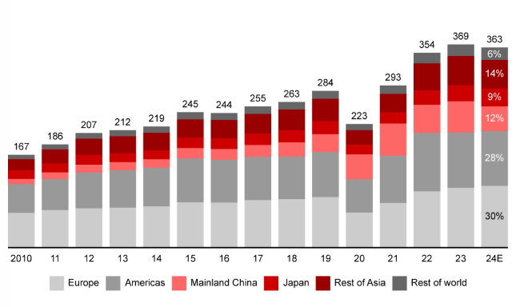

Task 2: Some observers believe the failure Waterford Wedgeworth was case of bad luck, others believe it was a failure of strategic management. Discuss both views and give your opinion.
(Approximately 250 words)

Task 3: Executive summary of assignment Write a brief summary of the findings of your research into an Irish company expanding abroad or an overseas company entering the Irish market.
(Approximately 200 words)

Name: ____________________________
Task 1 Answer Sheet

Name: ____________________________
Task 2 Answer Sheet

Name: ____________________________
Task 3 Answer Sheet

